**Ability Shetland Carer and Compassionate Leave Policy**

**Introduction**

Ability Shetland acknowledges that its employees may have to deal with the daily demands of caring for dependants, dealing with emergency situations and bereavement. It is recognised that, on occasion, it is possible for a clash of work and domestic issues to occur, which may require time off work, usually at short notice.

The Employment Relations Act 1999 provides a statutory right for employees to take a “reasonable” amount of time off work to deal with unexpected or sudden emergencies and to make any necessary longer-term arrangements. The emergency must involve a dependant of the employee and does not include an entitlement to pay. Ability Shetland will however in addition consider paid leave in certain circumstances where the annual leave entitlement of the individual concerned may be inadequate or inappropriate to the circumstances.

The following leave provisions should provide employees with adequate short and long-term solutions to meet caring responsibilities and deal with domestic problems and bereavement. They aim to encourage managers and employees to discuss sensitively and openly these difficulties in a mutually acceptable manner.

**SCOPE**

These leave provisions apply to all permanent and temporary employees. Part-time and job-share employees are entitled to the same provisions on a pro-rata basis.

1. **. PRINCIPLES**

Staff may apply for Carer or Compassionate Leave if they need to be absent from work in circumstances not covered by the provisions for sick leave, annual leave, maternity leave, or parental leave Compassionate Leave is not an entitlement but applications should be sympathetically considered in the light of individual circumstances.

3.1 The Team Leader, or in the case of the Team Leader applying for such leave a the Chair, are responsible for considering leave application for periods of up to **five** working days (e.g. a week) pro- rata for part-time staff or in special circumstances equivalent to **five** working days, e.g. over a two week period.

3.2 Where the Team Leader wishes to approve compassionate leave greater than these provisions such leave shall be unpaid unless otherwise authorised by the Chair of the Board of Trustees. An example of when this may be considered is in the case of an employee caring for a terminally ill dependant

3.3 Applications for compassionate leave should, whenever possible, be made in advance in writing to the Team Leader. Due to its nature it is accepted that on occasion applications for such leave will be made in retrospect. However, they should be made as soon as is reasonably practicable.

3.4 In all cases the Team Leader/Chair may request supporting evidence, with the exception detailed in 4.4. If not forthcoming, this may be regarded as sufficient reason to decline the compassionate leave request.

3.5 Leave requests in terms of this policy should be made where someone is not able to attend their work due to a reason specified below. It should not be awarded for compensatory time off because the employee has had to deal with a carer or compassionate circumstance out with their working hours.

1. **CATEGORIES FOR APPROVAL**

4.1 Compassionate leave with pay may be granted to help staff cope with the illness of a partner, close relative or dependant. Compassionate leave can be allowed in order to deal with the initial emergency but not for providing longer term nursing care. If leave is required to attend someone who is seriously ill either at home or in hospital, supporting medical evidence (if obtainable) should be produced as soon as practicable.

An initial emergency is one where the employee is contacted during working time and is required to attend to the immediate care needs of their partner/close relative/dependant because of illness. The employee may be granted compassionate leave for the time it takes to deal with the call, inform their manager, attend to the immediate care needs of their partner/close relative/dependant and then make arrangements for their continued care. Should the employee be required to stay at home for the rest of the day to care for their partner/close relative/dependant this falls under Time Off for Dependants (section 6). The same applies where an employee cannot attend work due to the illness of their partner/close relative/dependant.

The maximum time granted is 1 day, however it is normally expected that it would take less time to make these arrangements as all employees are expected to have contingency plans in place for these situations.

4.2 Although there may be exceptional cases, compassionate leave with pay is not normally intended to cover cases where a partner, close relative or dependant is in hospital. Special consideration should however be given to an application where, for example:

A young child is admitted to hospital, parental presence is called for and assistance is required with other family members.

In cases involving critical or terminal illness.

An escort is specifically required to take the patient to/from hospital. In this case the normal time off allowed would be the actual time required to travel to, attend and return from the hospital. Escorting a dependant to a GP, dentist or optician appointment is not covered by this clause.

4.3 Care of a Partner, Close Relative or Dependant on Discharge from Hospital

Compassionate leave with pay may be granted to allow staff to look after a partner, close relative or dependant to allow after-care immediately following discharge from hospital. This should be to allow staff to make arrangements for longer term after-care.

4.4 Bereavement

Applications for compassionate leave with pay for bereavement should be dealt with promptly and sympathetically and statements should be accepted without verification at this distressing time.

Staff may be granted up to five days paid leave (with a minimum of two days leave) for the death of a close relative

A more distant relative on the approval of the Chair of the Board of Trustees:

In cases of exceptional hardship, for example, where long distances (out with Shetland) or difficult journeys are involved, up to two additional days with pay may be granted.

In other circumstances up to one day’s leave with pay to attend the funeral of more distant relative/friend/or work colleague may be allowed.

**5. TIME OFF FOR DEPENDANTS**

The Team Leader (or in the case that the Team leader is requesting leave the Chair), may grant additional day’s unpaid leave, if requested, in addition to compassionate leave, or where compassionate leave is not appropriate. Unpaid leave may also be granted as an alternative to compassionate leave if the employee so requests.

**6 KEY ELEMENTS**

The key elements of the entitlement to time off for dependants are as follows:

* to help when a dependant is ill, gives birth*, or is injured or assaulted;
* to arrange for an ill or injured dependant to be cared for;
* because a dependant’s care arrangements are unexpectedly changed;
* as a result of the death of a dependant;
* to deal with an incident involving a child which occurs unexpectedly in school time.

* please refer to The Maternity, Paternity and shared leave Policy

A dependant is defined as a:

* spouse/partner;
* child;
* parent;
* a person who lives in the same house as the staff member
* a dependant will also include any person who reasonably relies on the employee for assistance on an occasion when the person falls ill or is injured or assaulted, or to make arrangements for the provision of care in the event of illness or injury.

**7. REQUESTING TIME OFF FOR DEPENDANTS**

The employee must tell the Team Leader as soon as possible that they need the time off and the likely duration. This request does not have to be made in writing.

**8 LEAVE FOR EMERGENCY DOMESTIC INCIDENCES**

There are also other emergency situations, which occasionally arise affecting you and your family or dependants that may require you to take time off work. These may include emergencies such as fire, flood and the

after effects of crime. In such circumstances the request for leave should be in writing to the Team Leader. Each request should be considered on its merits.

**9. LONGER TERM ARRANGEMENTS**

Where more time is needed, or where paid leave is exhausted, or it is necessary to make a commitment to a dependant for a longer time period, the following can be considered:

Such arrangements should normally be considered when the time off requirement is for more than five days.

* Temporary Amendment to Working Patterns

A change in either your pattern of weekly hours or a reduction in hours worked. Any reduced hours working would be for a specific period of time with the requirement to revert to your original contract at the end of an agreed period, unless a permanent change is agreed with your line manager.

* Annual Leave

With the agreement of the Team Leader (or Chair), annual leave may be taken

**APPENDIX I**

**Carer and Compassionate Leave Request Form**

To:

Name

I would like to apply for the following carer/compassionate leave:

First Day of Leave

Last Day of Leave

No. of Days Requested No. of Hours Requested

Number of carer/compassionate leave days/hours taken during the current leave year

Outstanding annual leave during the current leave year

Type of leave requested: -

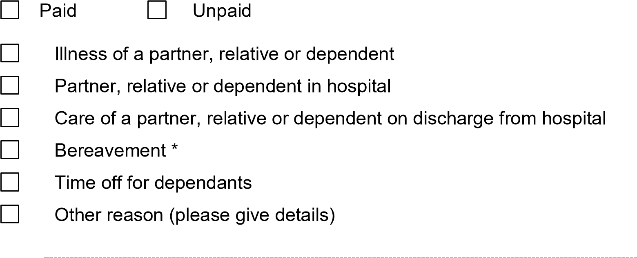

|  |
| --- |
| * Please indicate the deceased’s relationship to you: -        Are you the executor of the will? Yes No |

Please give further relevant details of reason for request:-

Employee Date



**Approved**: -

Paid 

Date  *signature*