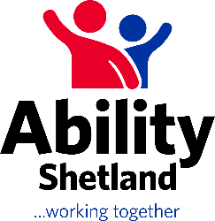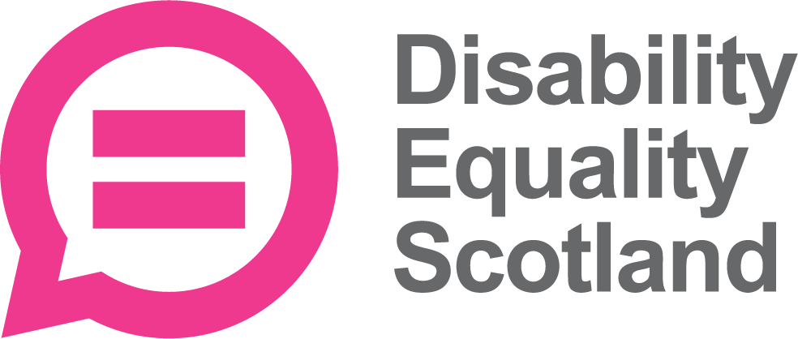

**Join the Shetland Access Panel – Your Voice Matters!**

Are you passionate about creating a more accessible Shetland for everyone? Disability Equality Scotland and Ability Shetland are excited to announce the formation of the Shetland Access Panel, and we need your help!

**About Us:** The Shetland Access Panel is a community initiative dedicated to improving accessibility for disabled people across the Shetland Islands. With the support of Disability Equality Scotland and Ability Shetland, we aim to identify and tackle barriers that prevent equal access to services, facilities, and opportunities.

**Why Join?**

* **Make a Difference:** Use your experiences and insights to influence local decision-making and improve accessibility in Shetland.
* **Be Heard:** Provide valuable feedback on local projects and policies, ensuring that the needs of disabled people are considered.
* **Build Community:** Connect with like-minded individuals and organisations working towards a common goal.
* **Develop Skills:** Gain experience in advocacy, teamwork, and community engagement.

**Who Can Join?** We welcome all disabled people who live in Shetland and are passionate about accessibility issues. Whether you have a visible or hidden disability, your lived perspective is crucial to our mission.

**How to Get Involved:**

* **Contact Us:** Reach out to Disability Equality Scotland or Ability Shetland to express your interest and learn more about the panel.
* **Stay Informed:** Follow us on social media and visit our websites for updates on meetings and events.
* **Participate:** Attend our meetings, share your experiences, and help us shape a more inclusive Shetland.

Together, we can make Shetland a place where everyone can participate fully and equally. Your voice can make a real difference. Join the Shetland Access Panel today and be part of the change!

**Contact Information:**

* Disability Equality Scotland: [access@disabilityequality.scot](mailto:access@disabilityequality.scot)
* Ability Shetland: [abilityshetland@shetland.org](mailto:abilityshetland@shetland.org)

Let's work together to build a more accessible future for Shetland!